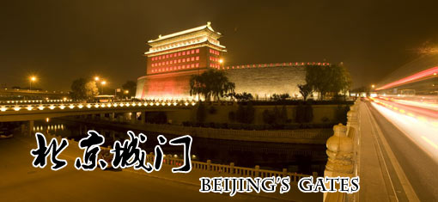
Click here and listen! 北京的城门

北京的城门是进出京城的通道，北京旧城有“里九外七皇城四”之说，就是说内城有九座城门，外城有七座城门，皇城有四座城门。 | Beijing’s Gates are basically the entrance of Beijing city. There is a saying that the ancient Beijing city had“9 inside, 7 outside, and 4 for the emperor.” It means that there are 9 gates inside the city, 7 gates outside the city and 4 gates in the forbidden city.
内城是老北京城的主体，九座城门按照顺时针方向分别是正阳门、宣武门、阜成门、西直门、德胜门、安定门、东直门、朝阳门、崇文门。它们各自有不同的用途和特征。目前仅保留正阳门的城楼、箭楼和德胜门的箭楼，其他的均已被毁掉。 | Inner city is the main structure of Beijing, the 9 gates following clockwise are Zhengyangmen, Xuanwumen, Fuchengmen, Xizhimen, Deshengmen, Andingmen, Dongzhimen, Chaoyangmen, Chongwenmen, which have their own usage and character. Now only the Zhengyangmen’s gate tower and watch tower and Deshengmen’s watch tower are remained. Other towers for all the gates are destroyed.
外城的七座城门按照顺时针方向分别是东便门、广渠门、左安门、永定门、右安门、广安门、西便门。这些门是为老百姓入城做小买卖、打短工、走亲戚用的。 | 7 gates outside city clockwise are Dongbianmen, Guangqumen, Zuo'anmen, Yongdingmen, You'anmen, Guang'anmen, Xibianmen. These gates are built for the residents in Beijing to do business, come to work and visit relatives.
而皇城的四座城门分别是天安门、地安门、东安门、西安门。这四扇门是为城里的文武百官进出宫廷用的。 | 4 royal gates are Tian'anmen, Di'anmen, Dong'anmen，Xi'anmen, which are for the officials entrancing the Forbidden City.

